Configuration

What is Configuration?
# Source: AI Source: Provided by: [Data Path: Persons Table -> ID Column: 1, Name_En Column: Motasem Essam] -> From: [ChatGPT] on [2/15/2026]
Configuration in Git
Configuration in Git refers to settings that control Git’s behavior for a user, a repository, or the system.
- It determines things like your name, email, editor, merge tool, aliases, and other preferences.
- Configurations are stored in different scopes depending on how broadly they apply.

Key points
# Source: AI Source: Provided by: [Data Path: Persons Table -> ID Column: 1, Name_En Column: Motasem Essam] -> From: [ChatGPT] on [2/15/2026]
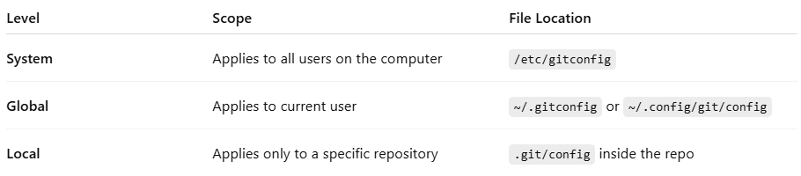
1. Git Configuration Levels
Level | Scope | File Location
System | Applies to all users on the computer | /etc/gitconfig
Global | Applies to current user | ~/.gitconfig or ~/.config/git/config
Local | Applies only to a specific repository | .git/config inside the repo
Local settings override global settings, and global overrides system settings.

1. System Level Configuration
# Source: AI Source: Provided by: [Data Path: Persons Table -> ID Column: 1, Name_En Column: Motasem Essam] -> From: [ChatGPT] on [2/15/2026]
- Scope: Applies to all users and all repositories on the computer.
- File Location: /etc/gitconfig
- Purpose: Sets default Git behavior for every user on the system.
- Example Settings: Default editor, default merge tool, system-wide color preferences.
Commands to work with system config:
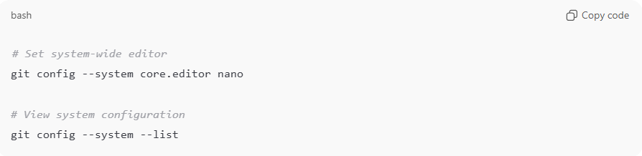
# Set system-wide editor
git config --system core.editor nano

# View system configuration
git config --system --list
Explanation:
- Any Git user on this computer will use these defaults unless overridden by global or local configuration.
- Useful for company machines or shared environments.

2. Global Level Configuration
# Source: AI Source: Provided by: [Data Path: Persons Table -> ID Column: 1, Name_En Column: Motasem Essam] -> From: [ChatGPT] on [2/15/2026]
- Scope: Applies to the current user, across all repositories they use.
- File Location: ~/.gitconfig or ~/.config/git/config
- Purpose: Personal settings for a user, like name, email, aliases, or preferred diff tool.
Commands to work with global config:
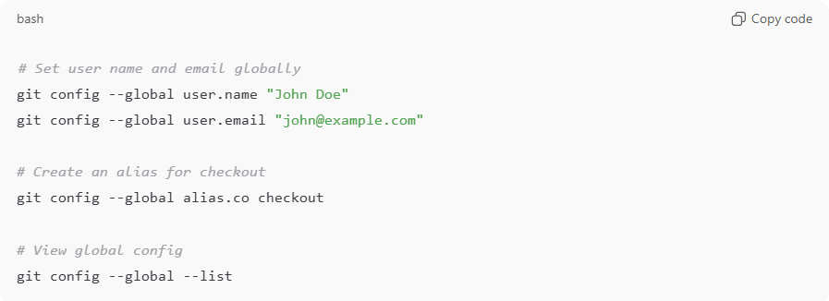
# Set user name and email globally
git config --global user.name "John Doe"
git config --global user.email "john@example.com"

# Create an alias for checkout
git config --global alias.co checkout

# View global config
git config --global --list
Explanation:
- These settings apply to all Git repositories of this user on the computer.
- Overrides system configuration if a setting exists at both levels.

3. Local Level Configuration
# Source: AI Source: Provided by: [Data Path: Persons Table -> ID Column: 1, Name_En Column: Motasem Essam] -> From: [ChatGPT] on [2/15/2026]
- Scope: Applies to a specific repository only.
- File Location: .git/config inside the repository
- Purpose: Repository-specific settings, like a unique author email, branch-specific merge options, or hooks.
Commands to work with local config:
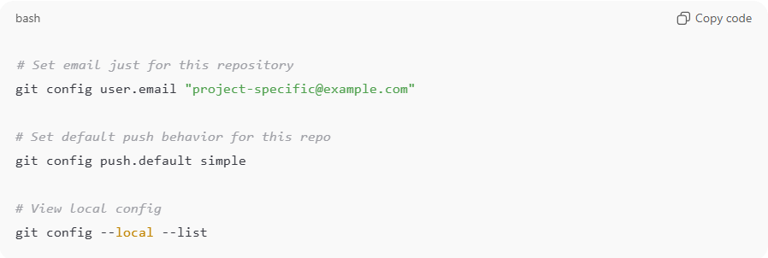
# Set email just for this repository
git config user.email "project-specific@example.com"

# Set default push behavior for this repo
git config push.default simple

# View local config
git config --local --list
Explanation:
- Local settings override global and system settings.
- Useful when working on a project that requires a different email, different editor, or different merge strategy.

Hierarchy / Priority of Git Configurations
# Source: AI Source: Provided by: [Data Path: Persons Table -> ID Column: 1, Name_En Column: Motasem Essam] -> From: [ChatGPT] on [2/15/2026]
Git applies settings in the following order:
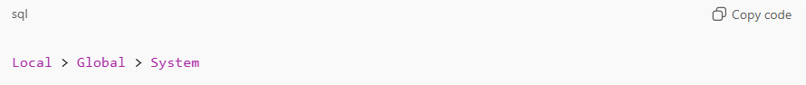
Local > Global > System
- If a setting exists in local, it takes precedence
- If it doesn’t exist in local, global is used
- If neither local nor global exist, system is used
Example:
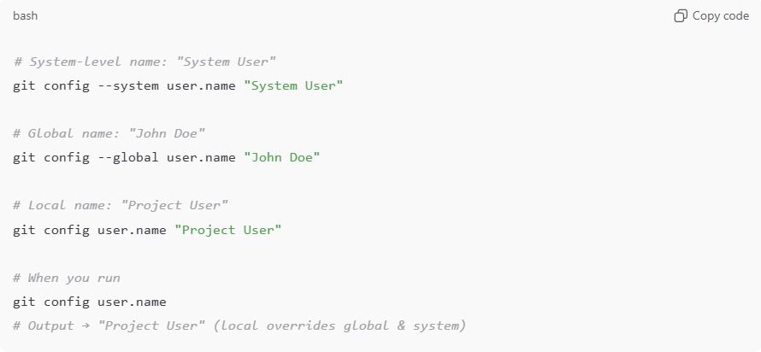
# System-level name: "System User"
git config --system user.name "System User"

# Global name: "John Doe"
git config --global user.name "John Doe"

# Local name: "Project User"
git config user.name "Project User"

# When you run
git config user.name
# Output → "Project User" (local overrides global & system)

💡 Memory trick:
# Source: AI Source: Provided by: [Data Path: Persons Table -> ID Column: 1, Name_En Column: Motasem Essam] -> From: [ChatGPT] on [2/15/2026]
System = all users → Global = current user → Local = this repo
Local always wins, global next, system last.

Common Configuration Settings
# Source: AI Source: Provided by: [Data Path: Persons Table -> ID Column: 1, Name_En Column: Motasem Essam] -> From: [ChatGPT] on [2/15/2026]
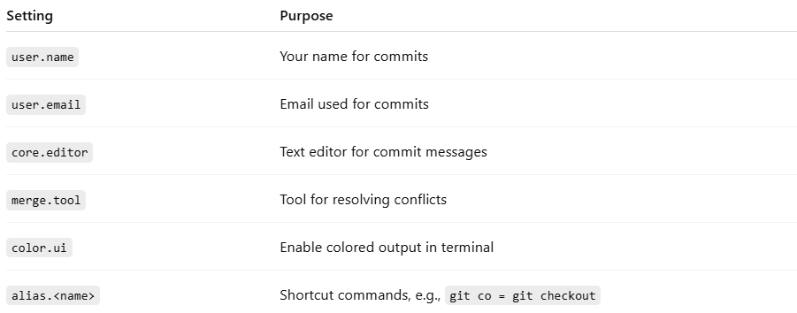
Setting | Purpose
user.name | Your name for commits
user.email | Email used for commits
core.editor | Text editor for commit messages
merge.tool | Tool for resolving conflicts
color.ui | Enable colored output in terminal
alias.<name> | Shortcut commands, e.g., git co = git checkout

Viewing Configurations
# Source: AI Source: Provided by: [Data Path: Persons Table -> ID Column: 1, Name_En Column: Motasem Essam] -> From: [ChatGPT] on [2/15/2026]
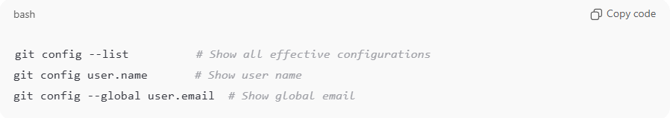
git config --list # Show all effective configurations
git config user.name # Show user name
git config --global user.email # Show global email

Setting Configurations
# Source: AI Source: Provided by: [Data Path: Persons Table -> ID Column: 1, Name_En Column: Motasem Essam] -> From: [ChatGPT] on [2/15/2026]
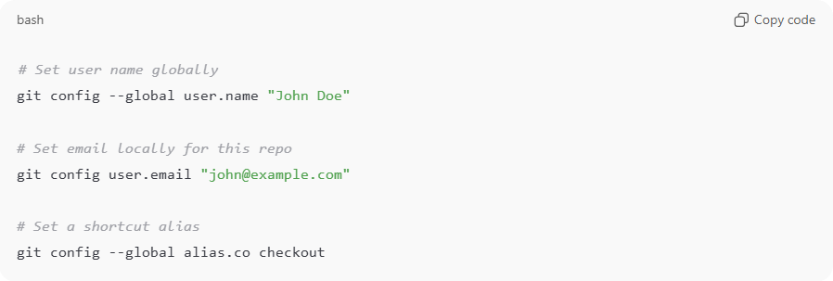
# Set user name globally
git config --global user.name "John Doe"

# Set email locally for this repo
git config user.email "john@example.com"

# Set a shortcut alias
git config --global alias.co checkout

Why Configuration is important
# Source: AI Source: Provided by: [Data Path: Persons Table -> ID Column: 1, Name_En Column: Motasem Essam] -> From: [ChatGPT] on [2/15/2026]
- Ensures commits have correct author information
- Makes Git personalized and efficient
- Enables consistent workflow across machines and repositories

💡 Memory trick:
# Source: AI Source: Provided by: [Data Path: Persons Table -> ID Column: 1, Name_En Column: Motasem Essam] -> From: [ChatGPT] on [2/15/2026]
Configuration = Git’s settings → tells Git who you are, how to behave, and shortcuts to use ✅

